

**INT 301 PROJECT(ASSIGNMENT -III)**



Sarabjit Kaur

*Computer Science and engineering*

RegNo:11708738 (KE021-B-67)

*Lovely Professional University, Jalandhar - Delhi G.T. Road, Phagwara, Punjab 144411* 

---------------------------------------------------------------------------------------------------------------------

* **INTRODUCTION**

CREATE A SIGNUP FORM AND FORM SHOULD VALIDATE ALL THE VALUES 5 INPUT BY USER.STORE ALL THE VALUES IN THE DATABASE.

ALSO FACILITATES OTHER OPTIONS FOR ADMIN

**LIKE :**

* SIGN UP details
* Delete database
* Modify Database
* Create database
* View Database

**THE PROJECT IS DIVIDED INTO 4 MODULES :**

* The Data Is Stored In The Database(**Mysql.php**).
* Enter New Database in **registration.php.**
* Login Into the database using **Login.php**
* Can see your profile by **profile.php**

Inside The Database Five Tables Have Been Created ,

* Username
* Password
* Gender
* Email
* Phone No.

The project uses mysql as database and php for functioning ,html , css and javascript for designing the web page. with **php(hypertext preprocessor)** we connect to database in mysql

* **Using the following code ( login_registration_system.sql ):**

-- phpMyAdmin SQL Dump

-- version 4.9.1

-- https://www.phpmyadmin.net/--

-- Host: 127.0.0.1

-- Generation Time: Jan 12, 2020 at 07:08 AM

-- Server version: 10.4.8-MariaDB

-- PHP Version: 7.3.11

SET SQL_MODE = "NO_AUTO_VALUE_ON_ZERO";

SET AUTOCOMMIT = 0;

START TRANSACTION;

SET time_zone = "+00:00";

/*!40101 SET @OLD_CHARACTER_SET_CLIENT=@@CHARACTER_SET_CLIENT */;

/*!40101 SET @OLD_CHARACTER_SET_RESULTS=@@CHARACTER_SET_RESULTS */;

/*!40101 SET @OLD_COLLATION_CONNECTION=@@COLLATION_CONNECTION */;

/*!40101 SET NAMES utf8mb4 */;

--

-- Database: `login_registration_system`

--

-- --------------------------------------------------------

--

-- Table structure for table `users`

--

CREATE TABLE `users` (

`user_id` int(11) NOT NULL,

`user_first_name` varchar(15) NOT NULL,

`user_last_name` varchar(15) NOT NULL,

`user_email` varchar(35) NOT NULL,

`user_password` varchar(35) NOT NULL

) ENGINE=InnoDB DEFAULT CHARSET=utf8mb4;

--

-- Dumping data for table `users`

--

INSERT INTO `users` (`user_id`, `user_first_name`, `user_last_name`, `user_email`, `user_password`) VALUES

(3, 'Md Ajmin', 'Pradhan', 'md.ajminpradhan@outlook.com', 'ajminpradhan'),

(4, 'Ariyan', 'Tanvir', 'ariyantanvir@protonmail.com', 'ariyantanvir'),

(5, 'Golam', ' Hider', 'hiderahmed@outlook.com', 'imhider'),

(6, 'Tushar', ' Ahmed', 'mr.prodhan912@gmail.com', 'imtushar'),

(7, 'MD Ajmin', ' Pradhan', 'mr.ajminpradhan@gmail.com', 'ajminpradhan'),

(8, 'dark', ' shadow', 'darkshadow@mymail.net', 'darkshadow'),

(9, 'Tamim Iqbal', ' Riyad', 'tamimiqbalriyad@mymail.net', 'tamimiqbalriyad@mymail.net'),

(10, 'Ariyan', ' Ahmed', 'ariyantanvir@mymail.net', 'jacksparow');

--

-- Indexes for dumped tables

--

--

-- Indexes for table `users`

--

ALTER TABLE `users`

ADD PRIMARY KEY (`user_id`);

--

-- AUTO_INCREMENT for dumped tables

--

--

-- AUTO_INCREMENT for table `users`

--

ALTER TABLE `users`

MODIFY `user_id` int(11) NOT NULL AUTO_INCREMENT, AUTO_INCREMENT=11;

COMMIT;

* **SIGNUP option will appear Using the following code ( registration.php):**

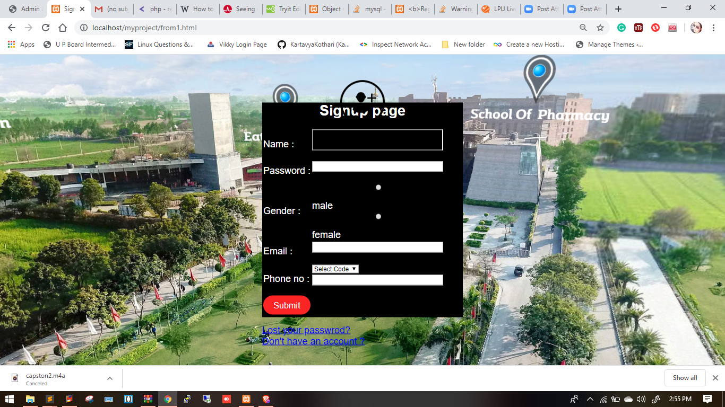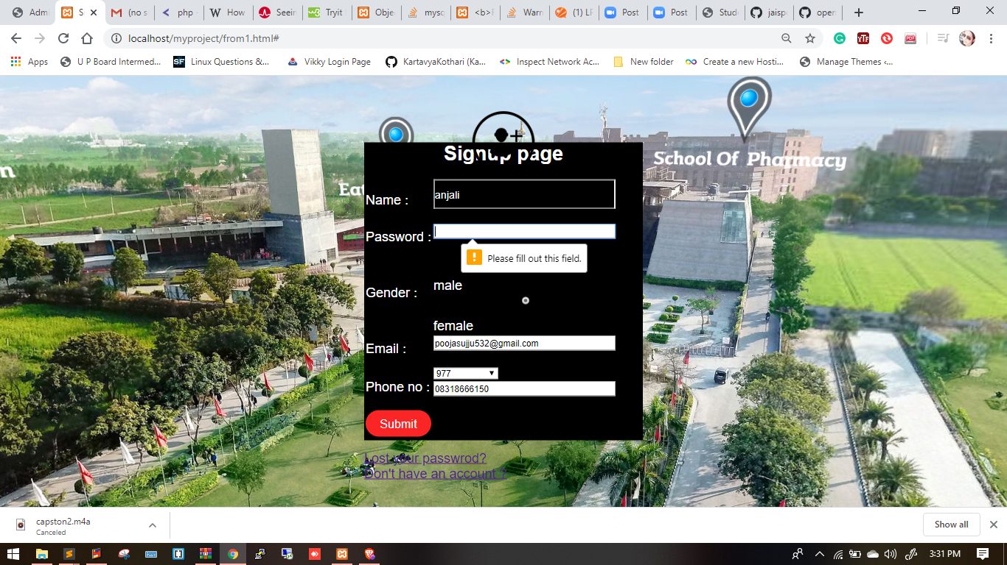

* **Required Data:**

**1. Login ACCOUNT**

* REGISTRATION NAME IS REQUIRED
* PASSWORD IS REQUIRED.

**2. ENTER NEW DATA**

* Name And Email,Gender ,Phone No And Password Confirmation Is Required.
* In Last It Will Ask Email And Password

<?php

//header file is included here

include 'inc/header.php';

//user file is included here

include 'lib/user.php';

$user = new user;

//if user logged in redirect user to index page

session::userLogin();

if($_SERVER['REQUEST_METHOD'] == 'POST' && isset($_POST['submit'])){

$userRegi = $user->userRegistration($_POST);

}

?>

<!-- body area started form here -->

<div class="container w-50 mt-5">

<div class="card">

<div class="card-header bg-dark">

<h5 class="text-white">Create a new account</h5>

</div>

<div class="card-body">

<?php

if(isset($userRegi)){

echo $userRegi;

}

?>

<form action="" method="POST">

<div class="form-group">

<label for="name">Name</label>

<input type="text" name="name" class="form-control" id="name">

</div>

<div class="form-group">

<label for="username">Username</label>

<input type="text" name="username" class="form-control" id="username">

</div>

<div class="form-group">

<label for="email">Email address</label>

<input type="email" name="email" class="form-control" id="email">

</div>

<div class="form-group">

<label for="password">Password</label>

<input type="password" name="password" class="form-control" id="password">

</div>

<div class="form-group">

<label for="cpassword">Confirm Password</label>

<input type="password" name="cpassword" class="form-control" id="cpassword">

</div>

<div class="form-check">

<input type="checkbox" name="terms" class="form-check-input" id="terms">

<label class="form-check-label" for="terms">I agree with terms and conditions</label>

</div>

<button type="submit" name="submit" class="btn btn-sm btn-primary mt-4">Submit</button>

</form>

</div>

</div>

</div>

* **LogIn option will appear Using the following code ( logiin.php):**

<?php

//header file is included here

include 'inc/header.php';

//user file is included here

include 'lib/user.php';

$user = new user;

//if user logged in redirect user to index page

session::userLogin();

if($_SERVER['REQUEST_METHOD'] == 'POST' && isset($_POST['submit'])){

$userLog = $user->userLogin($_POST);

}

?>

<!-- body area started form here -->

<div class="container w-50 mt-5">

<div class="card">

<div class="card-header bg-dark">

<h5 class="text-white">Login to your account</h5>

</div>

<div class="card-body">

<?php

if(isset($userLog)){

echo $userLog;

}

?>

<form action="" method="POST">

<div class="form-group">

<label for="username">Username</label>

<input type="text" name="username" class="form-control" id="username">

</div>

<div class="form-group">

<label for="password">Password</label>

<input type="password" name="password" class="form-control" id="password">

</div>

<button type="submit" name="submit" class="btn btn-sm btn-primary mt-4">Submit</button>

</form>

</div>

</div>

</div>

* **View profile details will appear Using the following code ( profile.php):**

<?php

//header file is included here

include 'inc/header.php';

//user file is included here

include_once 'lib/user.php';

$user = new user;

//catching the id which is thrown from index page

if(isset($_GET['id'])){

$id = $_GET['id'];

}

//user update function is created here

if($_SERVER['REQUEST_METHOD'] == 'POST' && isset($_POST['submit'])){

$userupdate = $user->userUpdate($id, $_POST);

}

?>

<!-- body area started form here -->

<div class="container w-50 mt-5">

<div class="card">

<div class="card-header bg-dark">

<h5 class="text-white">Update your details</h5>

</div>

<div class="card-body">

<form action="" method="POST">

<?php

if(isset($userupdate)){

echo $userupdate;

}

$userdata = $user->userById($id);

if($userdata){

foreach($userdata as $data){ ?>

<div class="form-group">

<label for="name">Name</label>

<input type="text" name="name" class="form-control" value="<?php echo $data['user_name'] ?>" id="name">

</div>

<div class="form-group">

<label for="username">Username</label>

<input type="text" name="username" class="form-control" value="<?php echo $data['user_username'] ?>" id="username">

</div>

<div class="form-group">

<label for="email">Email address</label>

<input type="email" name="email" class="form-control" value="<?php echo $data['user_email'] ?>" id="email">

</div>

<div class="form-group">

<label for="password">Password</label>

<input type="text" name="password" class="form-control" value="<?php echo $data['user_password'] ?>" id="password">

</div>

<div class="form-group">

<label for="cpassword">Confirm Password</label>

<input type="text" name="cpassword" class="form-control" value="<?php echo $data['user_password'] ?>" id="cpassword">

</div>

<button type="submit" name="submit" class="btn btn-sm btn-primary mt-4">Submit</button>

<a href=""><button type="submit" name="submit" class="btn btn-sm btn-danger mt-4">Delete</button></a>

<?php }

} ?>

</form>

</div>

</div>

</div>